**Request a package pickup: Use case description**

The following is a breakdown of the use case Request a package pickup that is specific to customers placing the request on the company website:

|  |  |  |
| --- | --- | --- |
| Use case name: | Request a package pickup. | |
| Scenario: | Requesting a package pickup online. | |
| Triggering event: | The customer visits the company’s website and requests a package pickup. | |
| Brief description: | The customer sends a request to On the Spot Courier Services through the company website for a package pickup. Information about the package (“deliver to” address, size, weight, type of service) is entered by the customer and the system calculates cost and prints mailing labels and receipts. Pickup time is calculated and scheduled so that the customer can view it. | |
| Actors: | Customer. | |
| Related use cases: | Pickup a package. | |
| Stakeholders: | Customer, Employee. | |
| Preconditions: | The customer must already have an account on the company website. | |
| Postconditions: | A package pickup request is created.  The customer account is updated with the new package pickup request. | |

|  |  |  |
| --- | --- | --- |
| Flow of activities: | Actor | System |
|  | 1. Customer enters “deliver to”  address  2. Customer selects size and  weight category of package.  3. Customer enters the service  type.  4. Customer requests mailing  labels and receipts to be  printed. | 1.1 Address is stored in the  system.  2.1 Size and weight of the  package are stored in the  system.  3.1 Service type is stored in the  system.  3.2 System calculates the cost  3.3 System schedules pickup and  displays estimated pickup  time  4.1 System creates mailing label  and receipts. |
| Exception conditions: | 1.1 Address entered is not valid, so the address must be re-entered.  4.1 System fails to create mailing labels and receipts; the label  must be created manually. | |

**Request a package pickup: Activity Diagram**

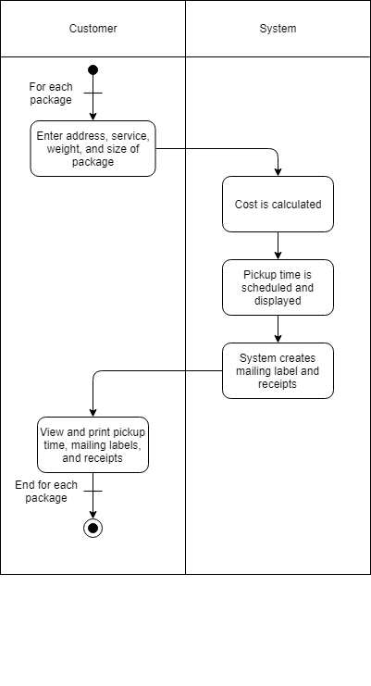

**Request a package pickup: System Sequence Diagram**

